Lab 4 Submission

Advanced Software Engineering

**Team 1_2** – Srichakradhar Reddy Nagireddy (32) & Sathwik Banginimatam (5)

# Ionic App

## OMDB API

We have used the [OMDb API](http://www.omdbapi.com/) - a RESTful web service similar to IMDB to obtain movie information, but the only difference is that it open to the public and is contributed and maintained by the users (all content and images).

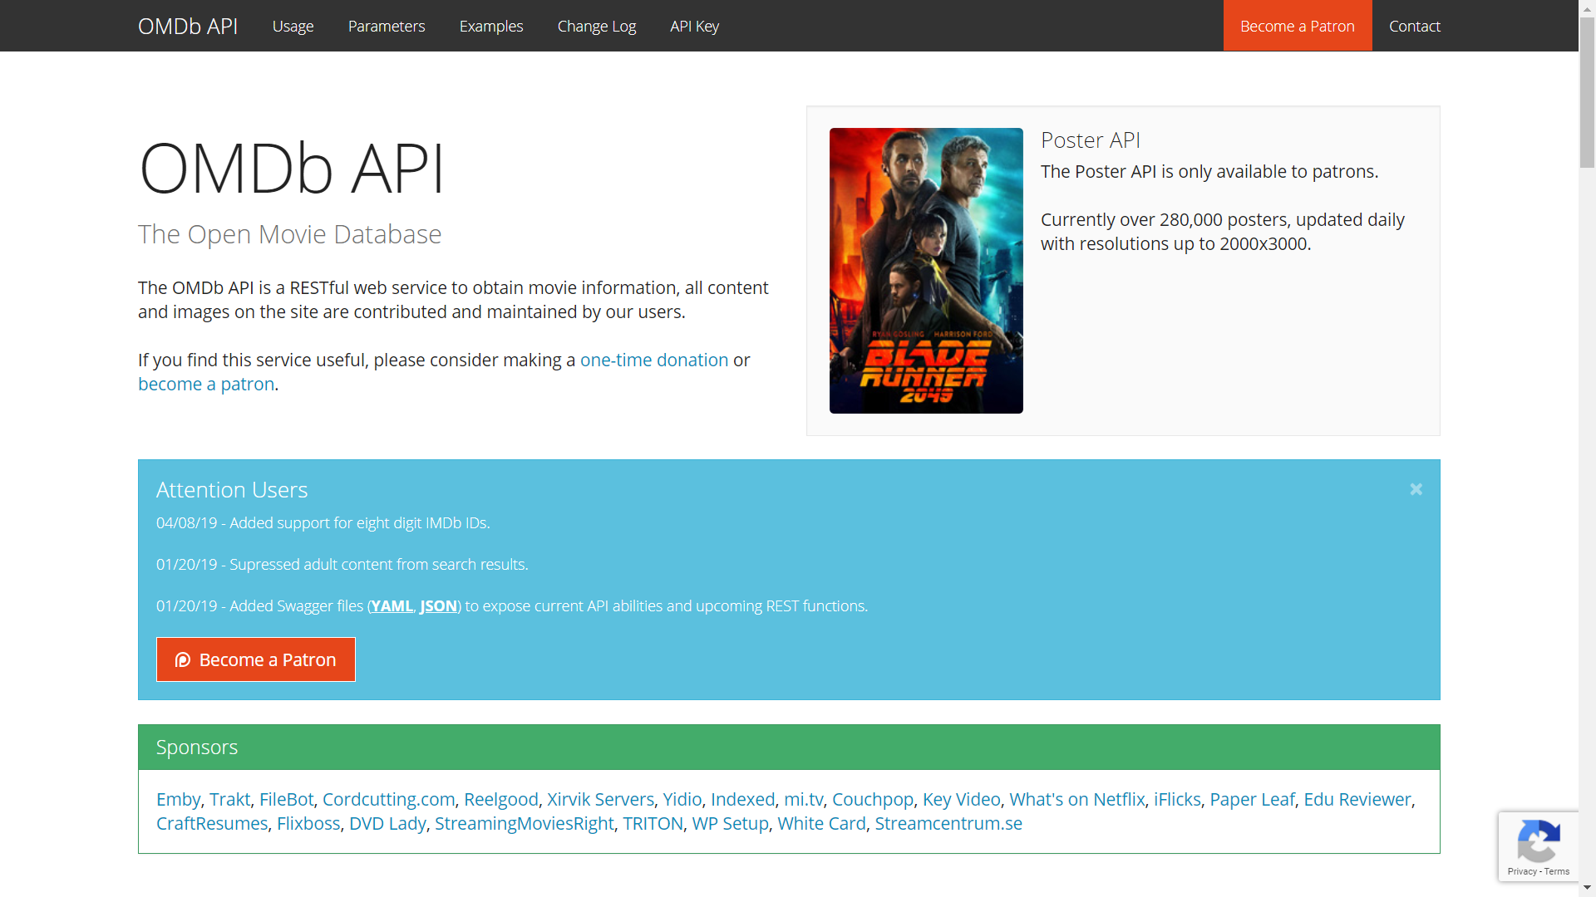

### Example:

#### Request:

<http://www.omdbapi.com/?t=Batman>

#### Response:

{"Title":"Batman","Year":"1989","Rated":"PG-13","Released":"23 Jun 1989","Runtime":"126 min","Genre":"Action, Adventure","Director":"Tim Burton","Writer":"Bob Kane (Batman characters), Sam Hamm (story), Sam Hamm (screenplay), Warren Skaaren (screenplay)","Actors":"Michael Keaton, Jack Nicholson, Kim Basinger, Robert Wuhl","Plot":"The Dark Knight of Gotham City begins his war on crime with his first major enemy being the clownishly homicidal Joker.","Language":"English, French, Spanish","Country":"USA, UK","Awards":"Won 1 Oscar. Another 8 wins & 26 nominations.","Poster":"https://m.media-amazon.com/images/M/MV5BMTYwNjAyODIyMF5BMl5BanBnXkFtZTYwNDMwMDk2._V1_SX300.jpg","Ratings":[{"Source":"Internet Movie Database","Value":"7.5/10"},{"Source":"Rotten Tomatoes","Value":"72%"},{"Source":"Metacritic","Value":"69/100"}],"Metascore":"69","imdbRating":"7.5","imdbVotes":"323,942","imdbID":"tt0096895","Type":"movie","DVD":"25 Mar 1997","BoxOffice":"N/A","Production":"Warner Bros. Pictures","Website":"N/A","Response":"True"}

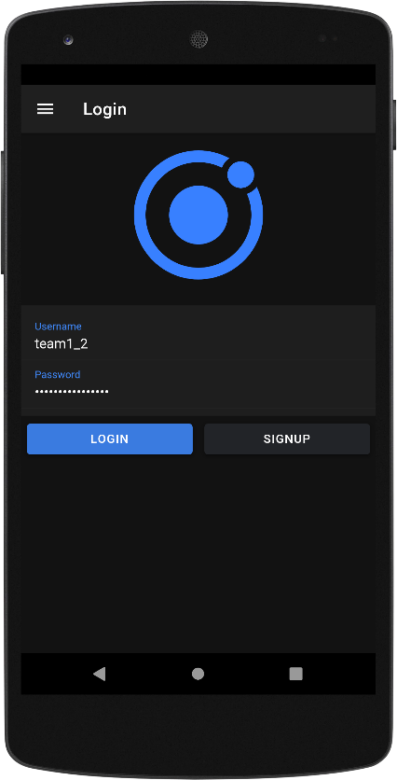 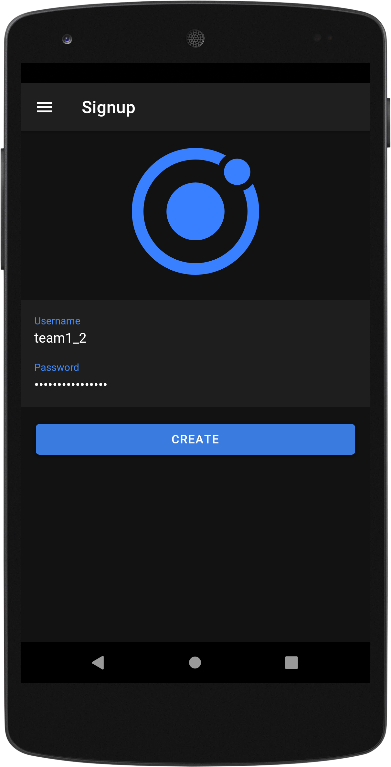

**Sign up and Login screens**

User can sign up with a username and a password and needs to login with the same credentials.

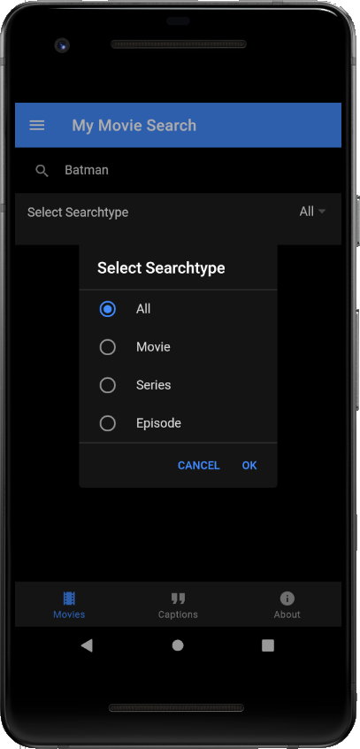 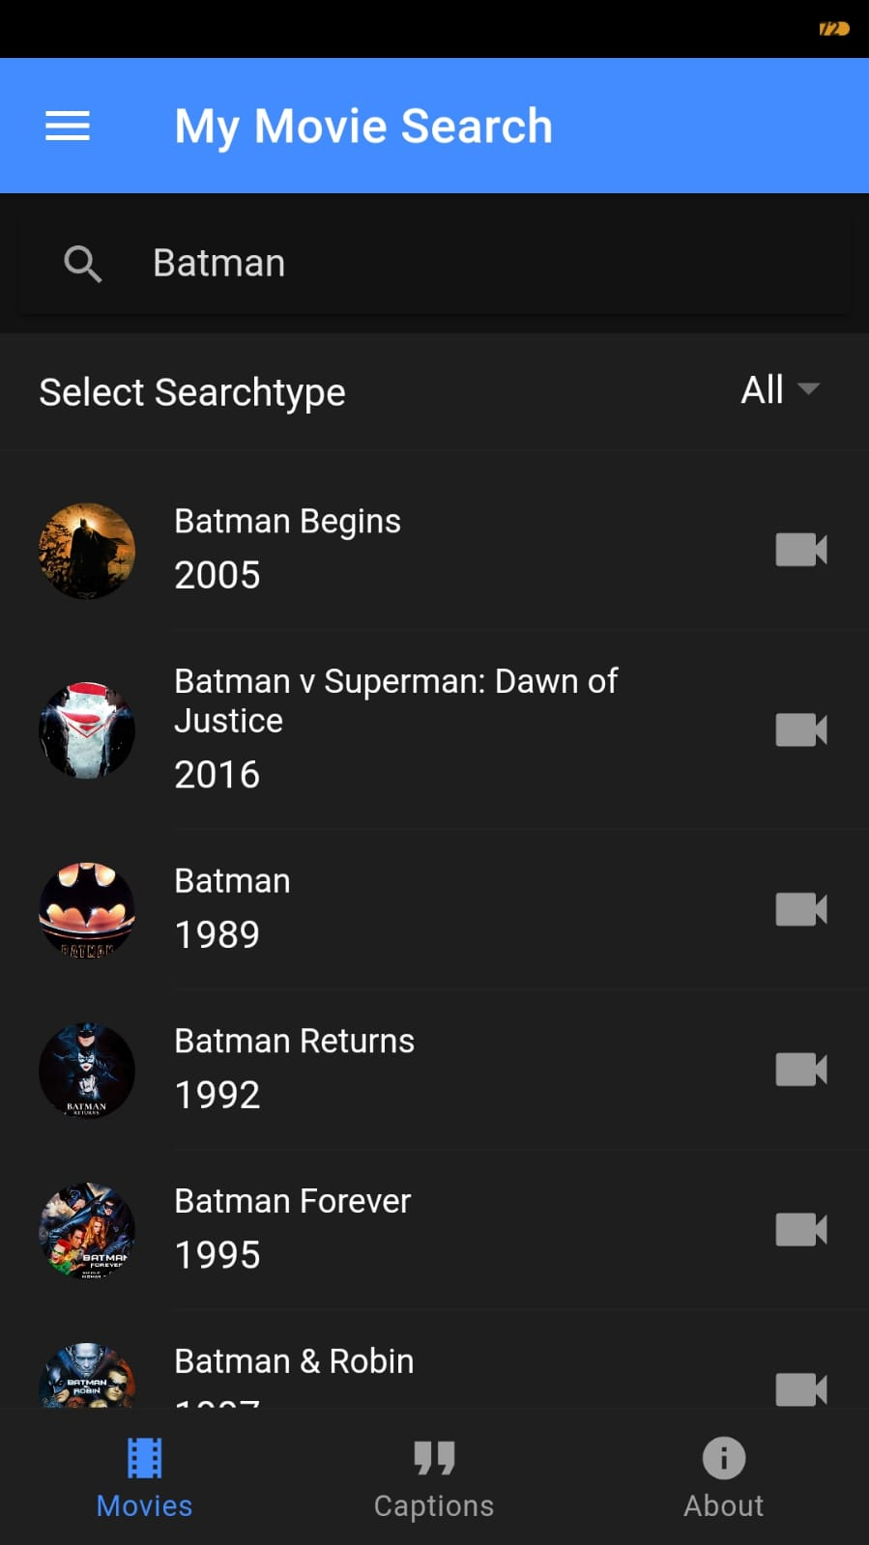 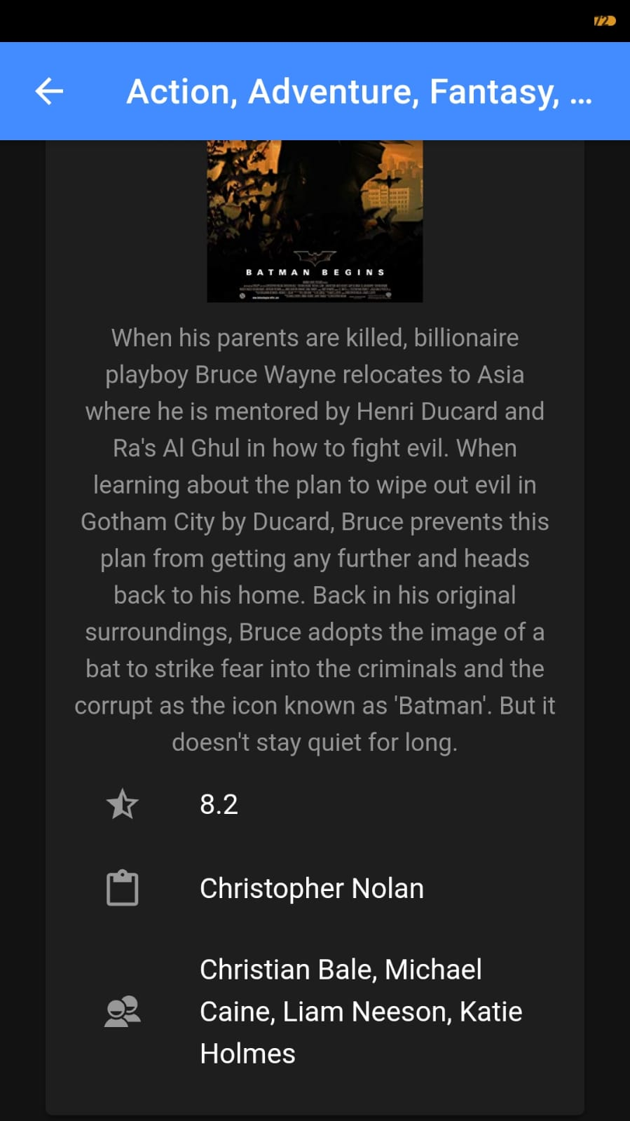

**Movie Search, List and Details screens**[Reference](https://github.com/vagnersabadi/ionic4-api-movies) for Movies API

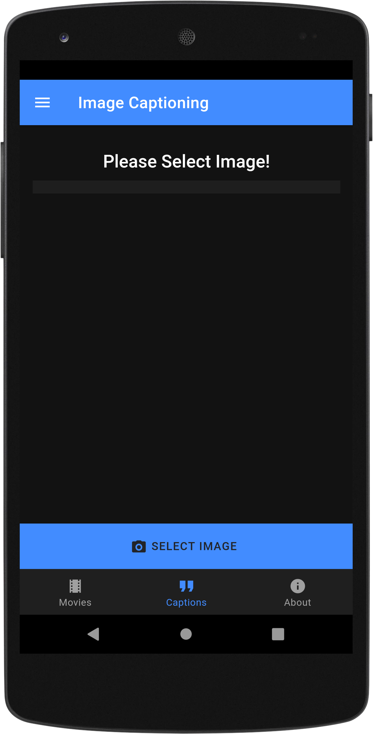 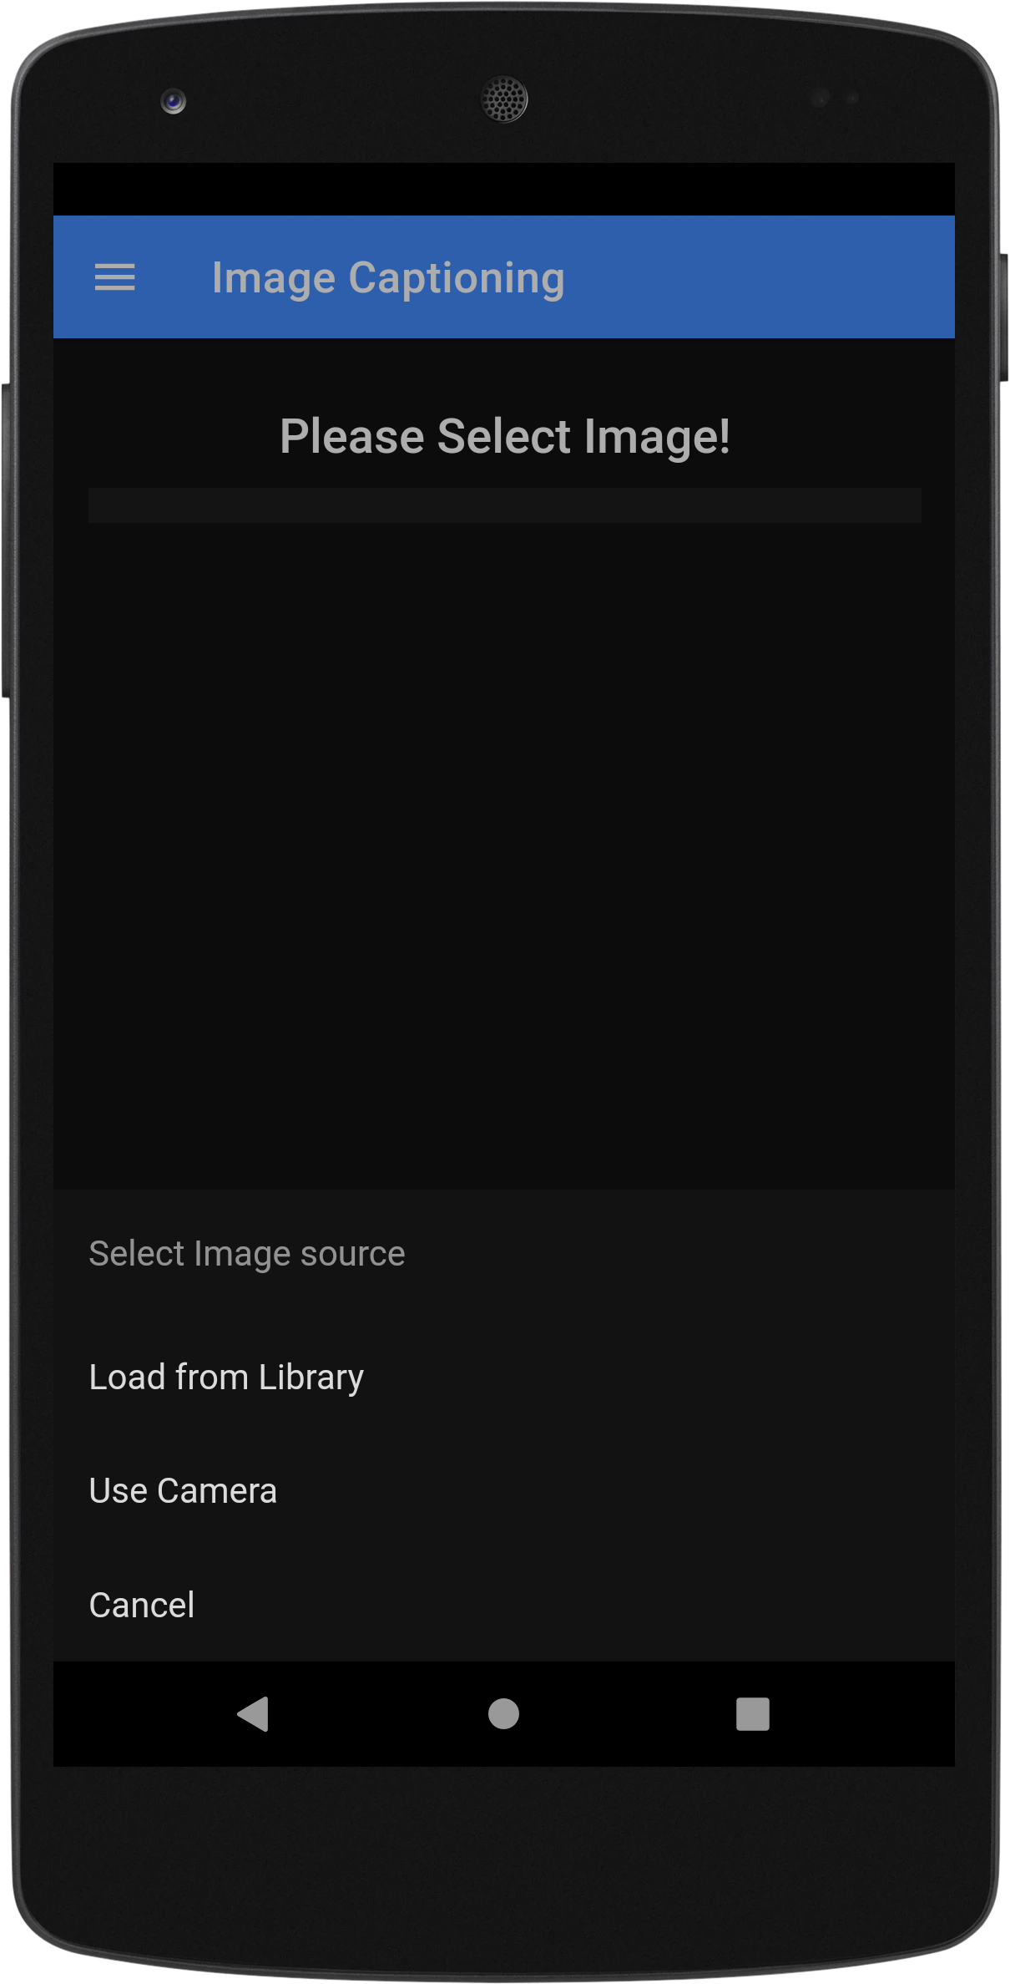 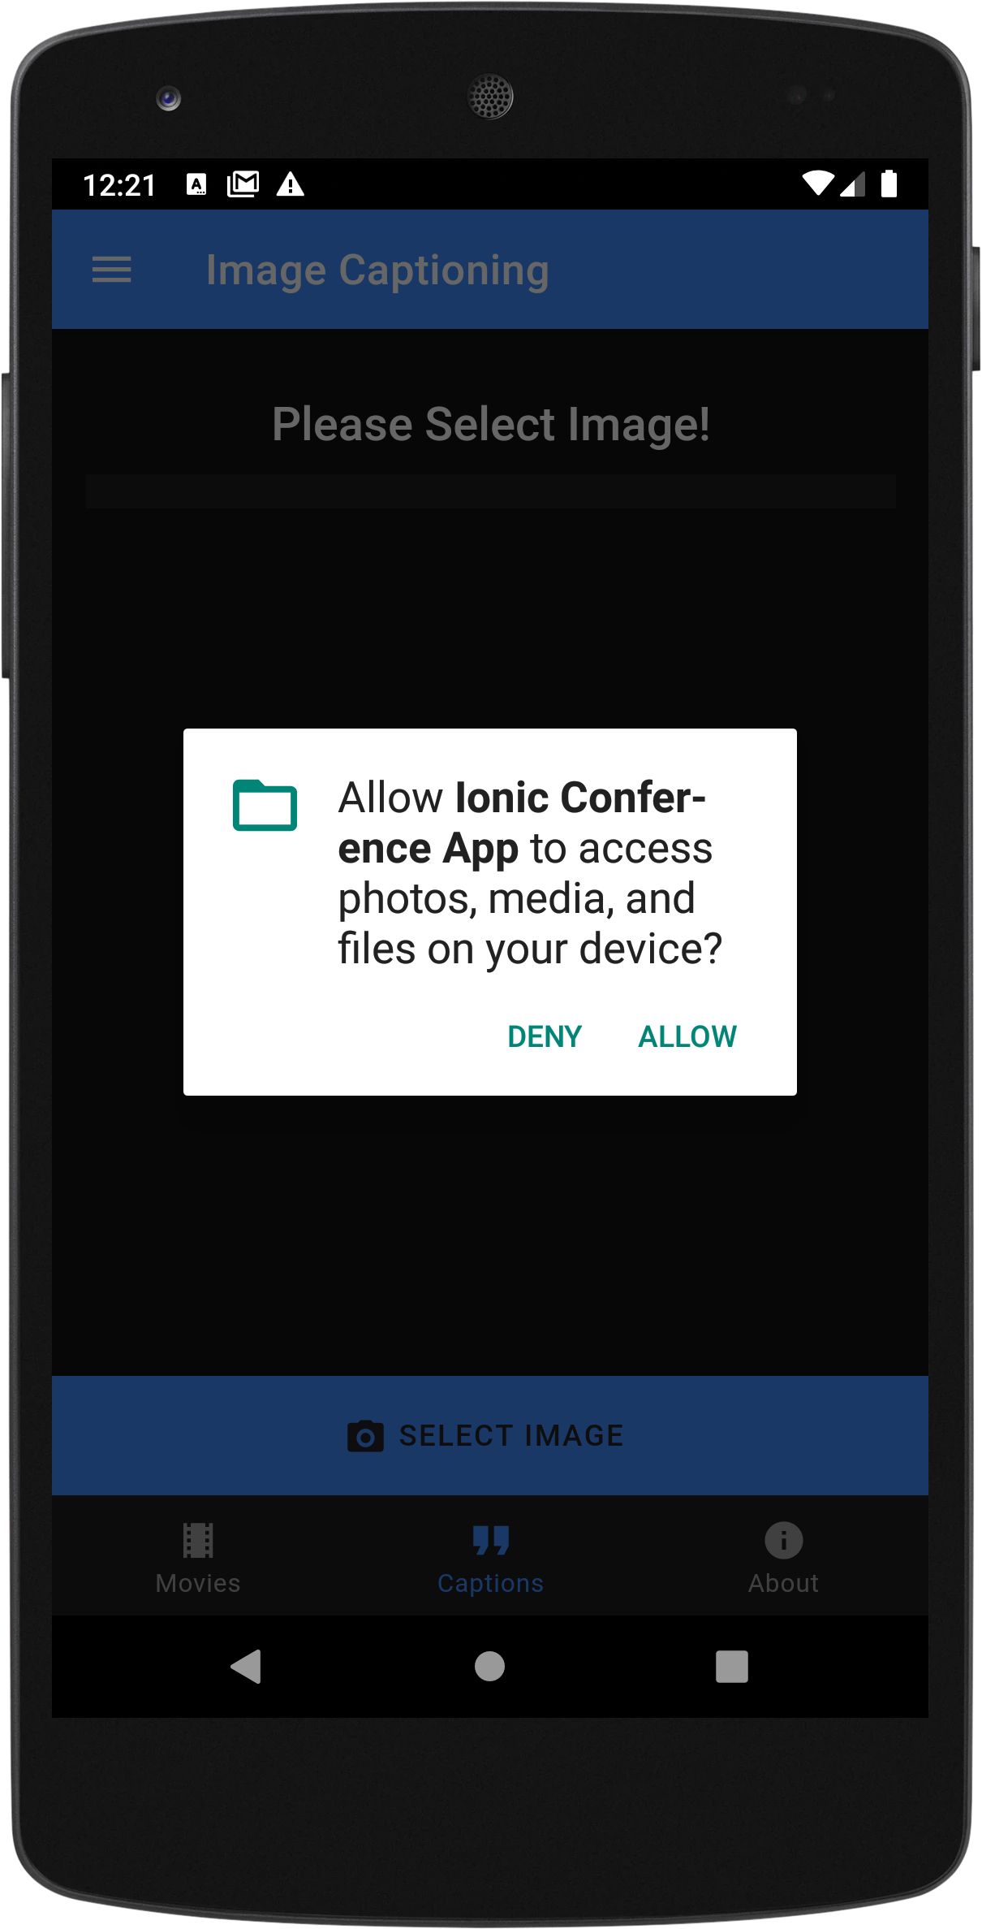

**Image Captioning API** – **Home Screen, Action Sheet and Permission** screens



Cloudmersive provides Image Recognition and Processing APIs that lets us use **Machine Learning** to recognize and process images, like

* Validate APIs
* Natural Language Processing (NLP) APIs
* Optical Character Recognition (OCR) APIs
* Barcode APIs
* Image and Face Recognition and Processing APIs
* Virus Scan APIs
* Document and Data Conversion APIs

and also perform image modification operations.

We have used **Image recognition and description API** to generate an English language text description of the image as a sentence.

Parameters:

**imageFile**\*: file(formData) - Image file to perform the operation on. Common file formats such as PNG, JPEG are supported.

**Response content type**: application/json

**Code**: 200, **Description**: OK

Response:

{  
 "Successful": true,  
 "Highconfidence": true,  
 "BestOutcome": {  
 "ConfidenceScore": 0,  
 "Description": "string"  
 },  
 "RunnerUpOutcome": {  
 "ConfidenceScore": 0,  
 "Description": "string"  
 }  
}

## **ImageDescriptionResponse: object**

Result of recognizing an image

**Successful:** boolean

*Was the image processed successfully?*

**Highconfidence:** boolean

*Is the resulting best outcome recognition a high confidence outcome?*

**BestOutcome:** [RecognitionOutcome](https://api.cloudmersive.com/docs/image.asp" \l "/definitions/RecognitionOutcome)

*The best Machine Learning outcome*

**RunnerUpOutcome:** [RecognitionOutcome](https://api.cloudmersive.com/docs/image.asp" \l "/definitions/RecognitionOutcome)

*Best backup ("runner up") Machine Learning outcome*

**Endpoint**: <https://api.cloudmersive.com/image/recognize/describe>

**Method**: POST

**References**:

1. [Swagger](https://api.cloudmersive.com/swagger/index.html?urls.primaryName=Image%20Recognition%20and%20Processing%20API)
2. [Docs](https://api.cloudmersive.com/docs/image.asp)

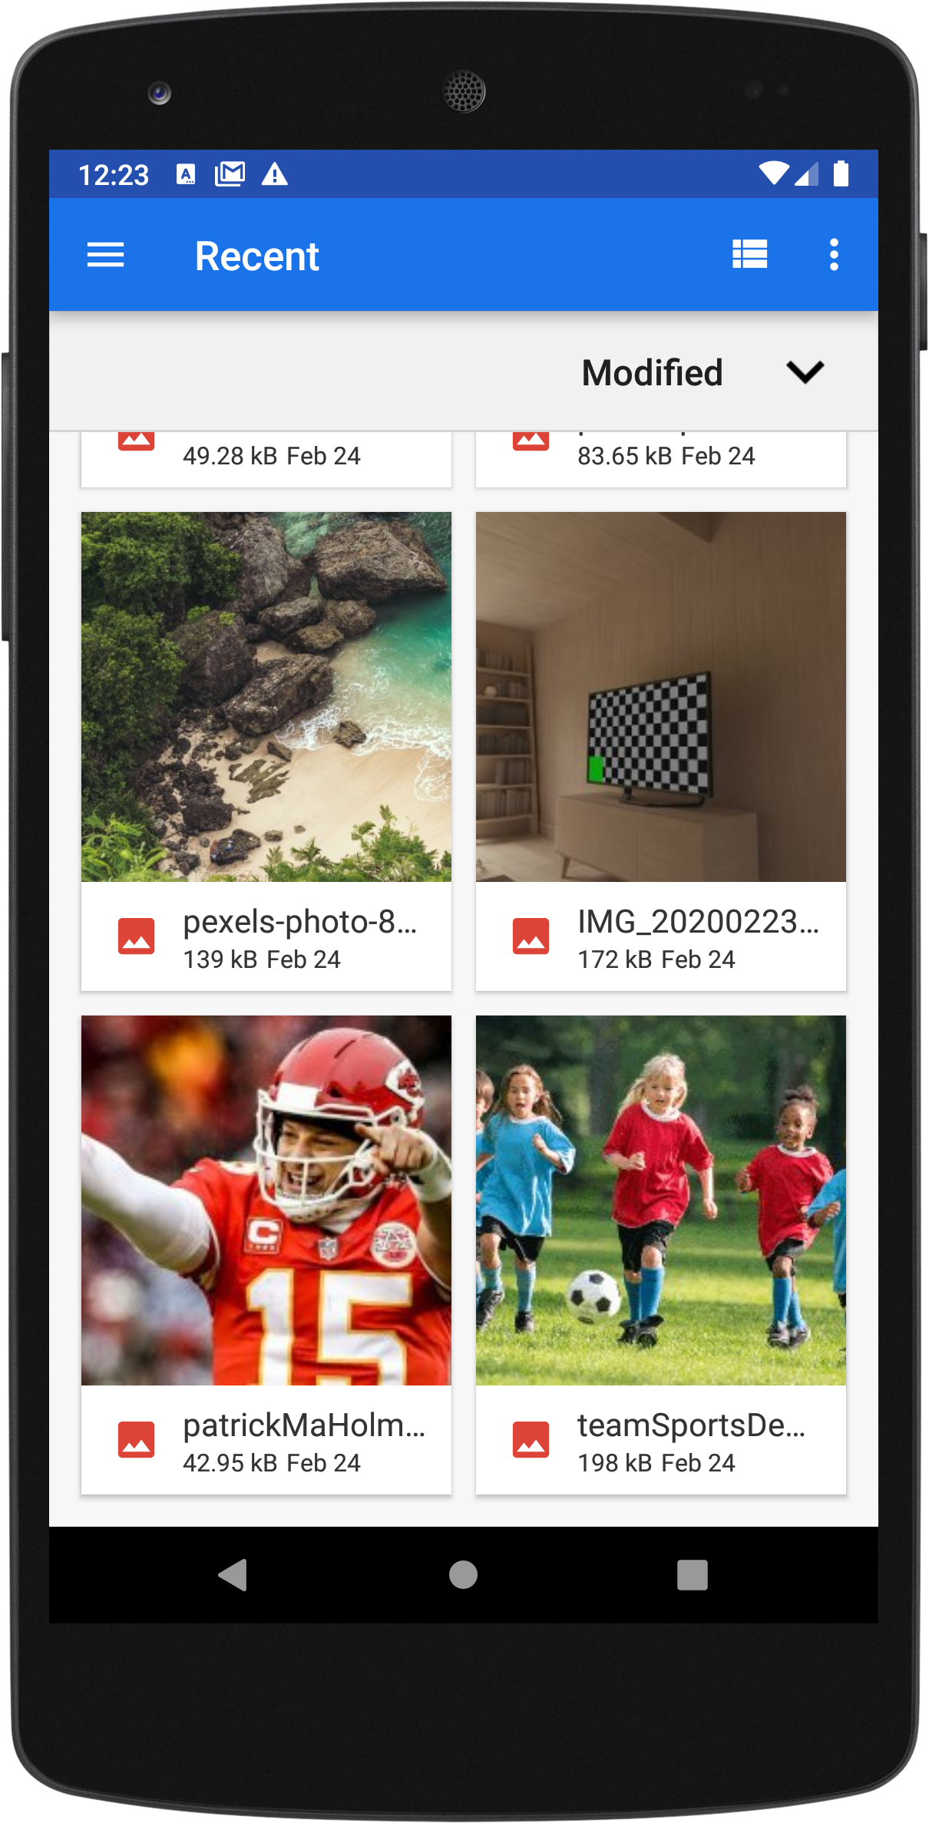 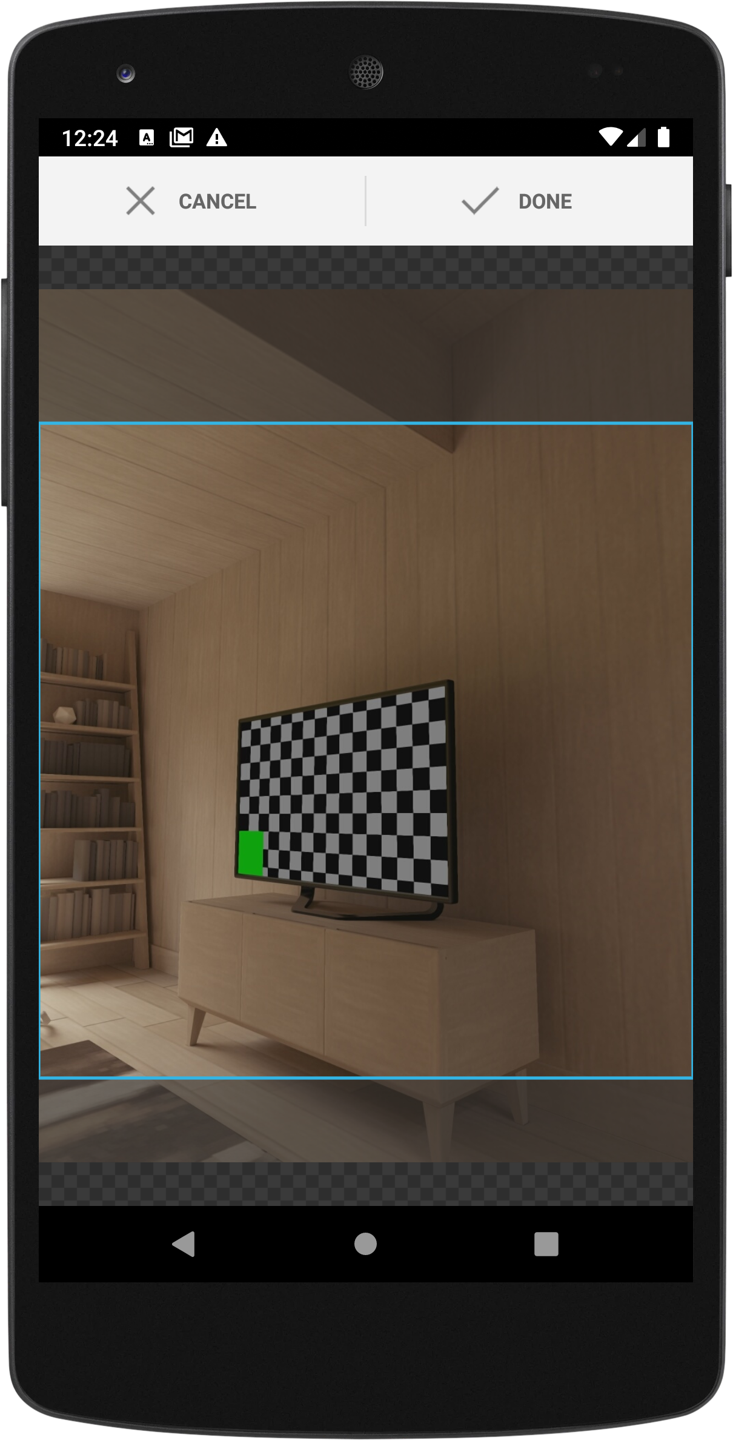 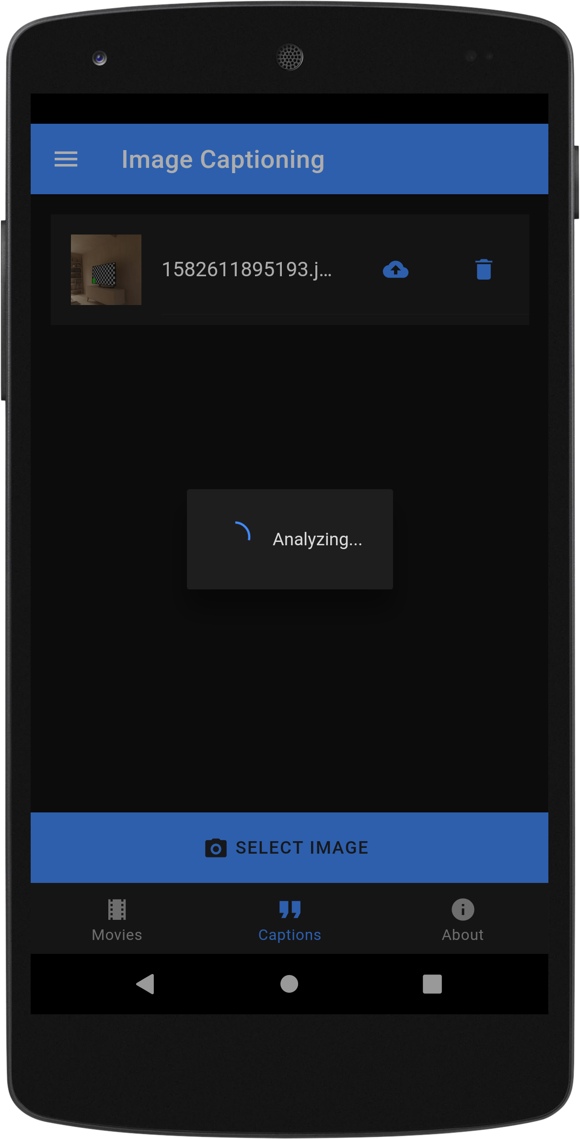

**Image selection – Cropping – Loader screens**

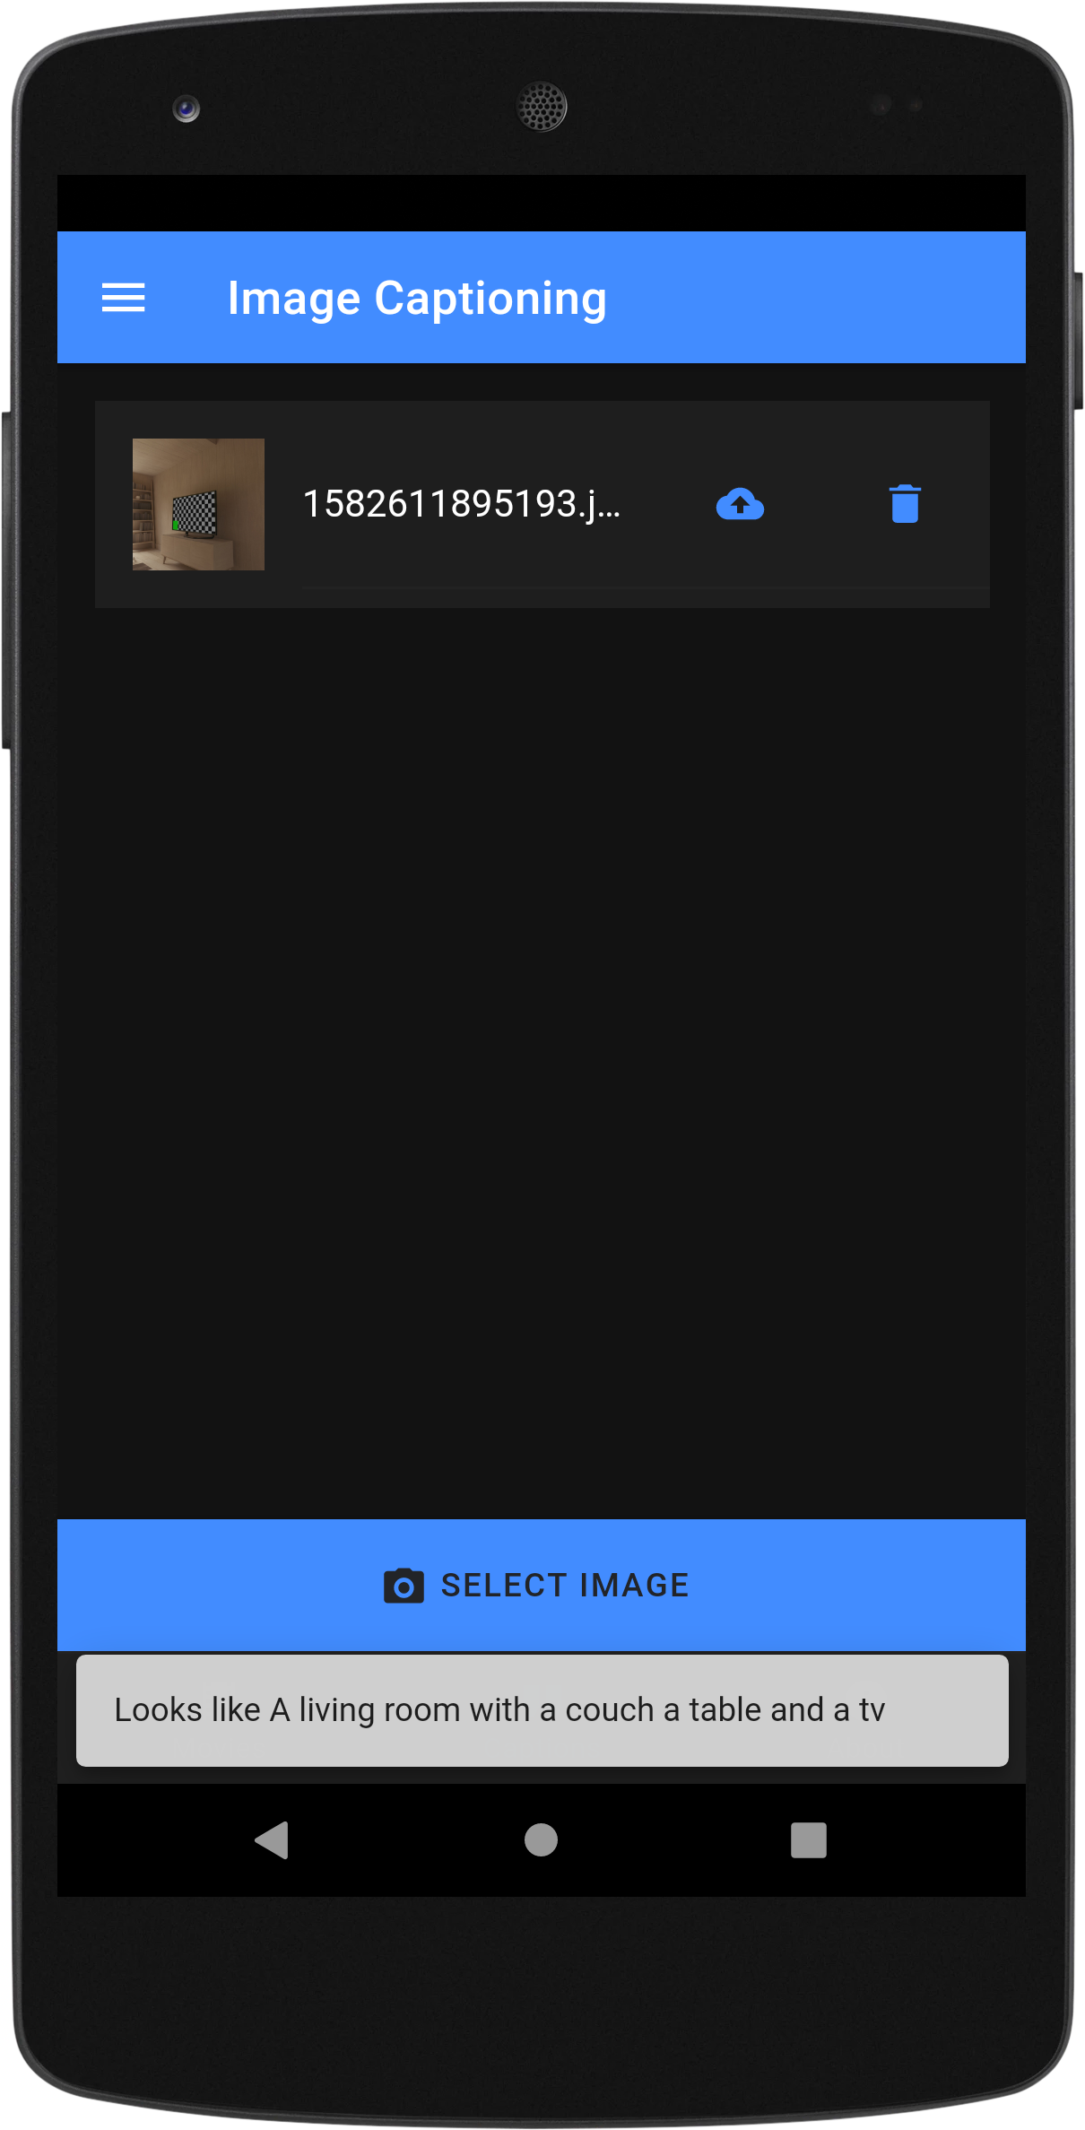 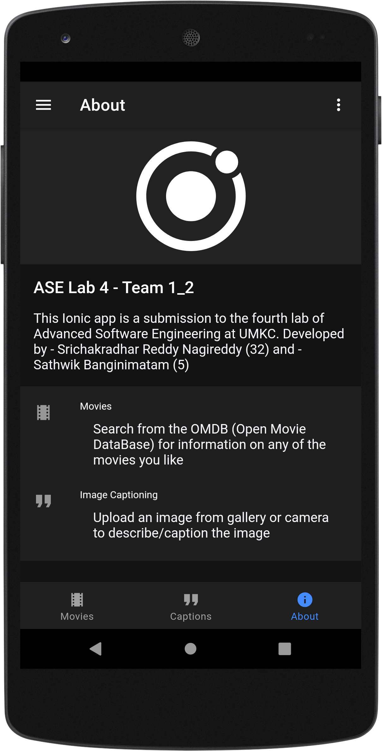

**Response and About screens**

Tests

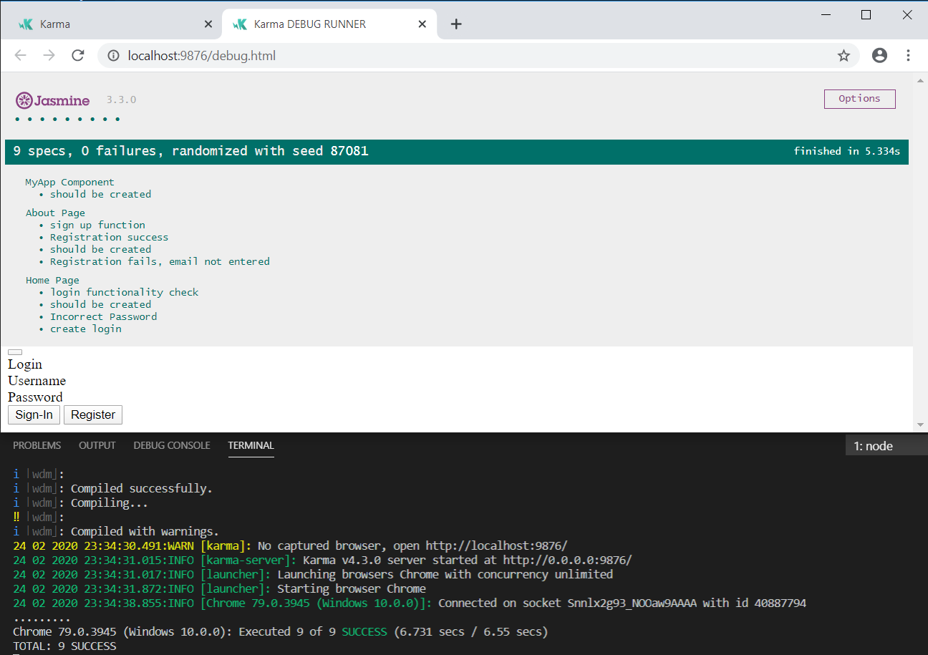

Tests were written in jasmine and have been successfully executed.

Environment:

1. Hybrid Framework: Ionic 6
2. MVVM Framework: Angular 8
3. OS: Android Pie
4. Android Developer Tools - API 28
5. IDE: VS Code